TASK | Easing/ lubricating fluid used on components and expels water or moisture
LOCATION OF USE | Workshop and field engineers |  | Assessment  No |  | 024
PRODUCT NAME | Maintenance Spray
DESCRIPTION OF SUBSTANCE
MANUFACTURER | Henkel
MANUFACTURERS CONTACT | Henkel Limited  Wood Lane End  Hemel Hempstead  HP2 4RQ  Great Britain  Phone: +44 1442278000  Emergency: 01442278497  ua-productsafety.uk@uk.henkel.com
ASSESSOR | Martin Monaghan CMIOSH |  | Date |  | 04 12 25
TITLE | Health and Safety Consultant |  | Review by |  | 04 12 27
Personnel Performing Task  (Please list below)  Technicians/ Fitters/ Workshop Operatives |  | Time Spent  (Minutes/day)  As and when required, amounting to a few minutes per day | Training Given 
 |  |  | Yes

MSDS Revision Date | Hazard Statement
06 07 2018 | H222 Extremely flammable aerosol.  H229 Pressurised container: May burst if heated.  H315 Causes skin irritation.  H336 May cause drowsiness or dizziness.  H411 Toxic to aquatic life with long lasting effects

Assessment to be conducted in Association with Hazard Data Sheets, a full current copy of which must be attached to this assessment.

Please denote the hazardous properties of the substances used in the task with a 

NEW INTERNATIONAL GLOBALLY HARMONISED HAZARD SYMBOLS
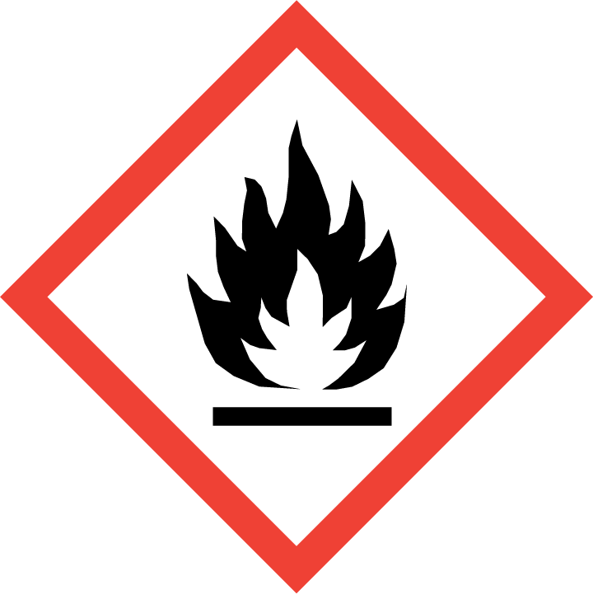 | 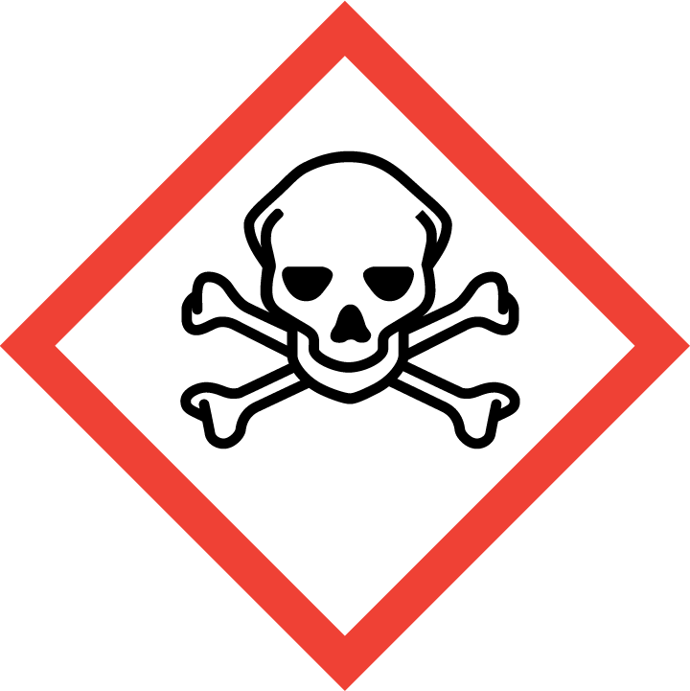 | 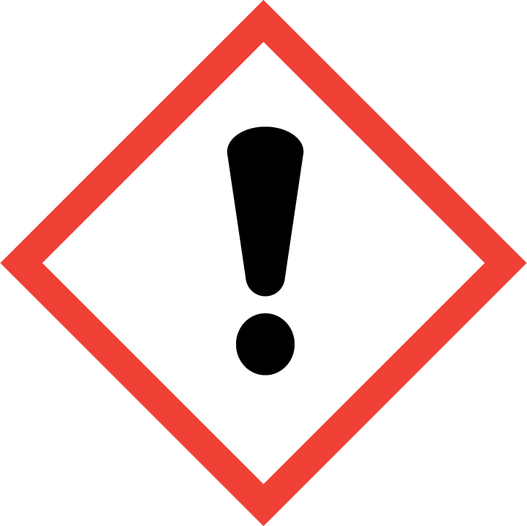 | 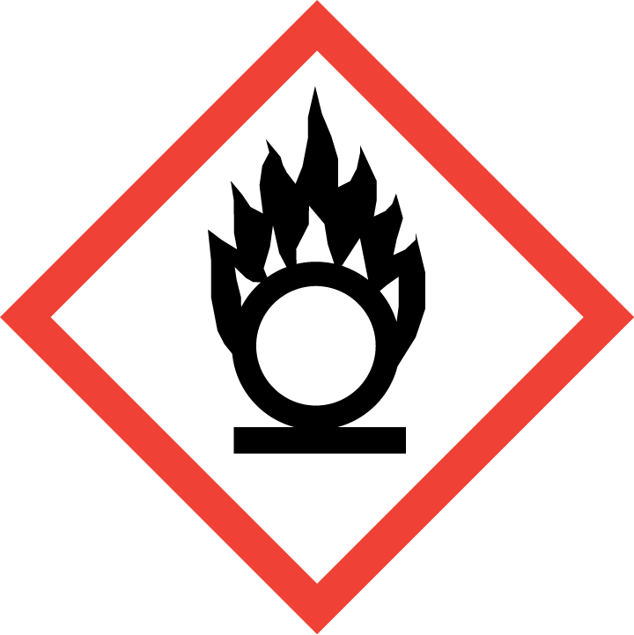 | 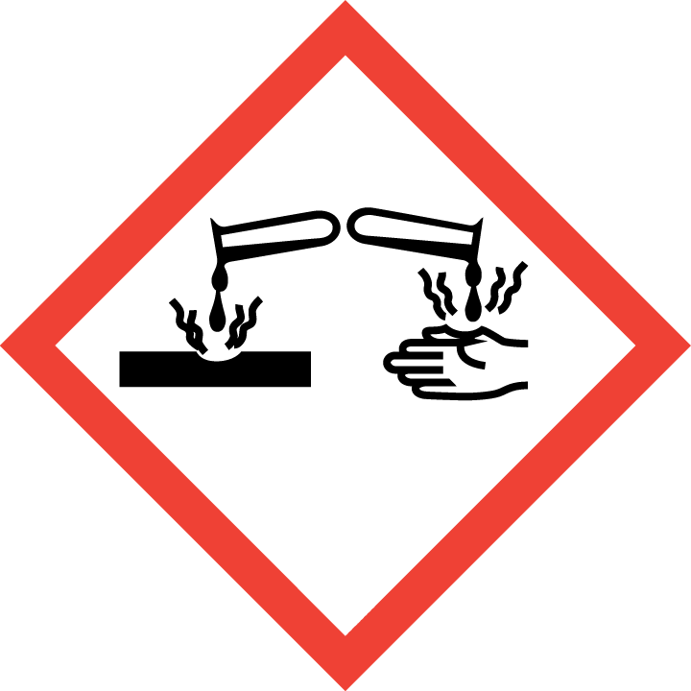 | 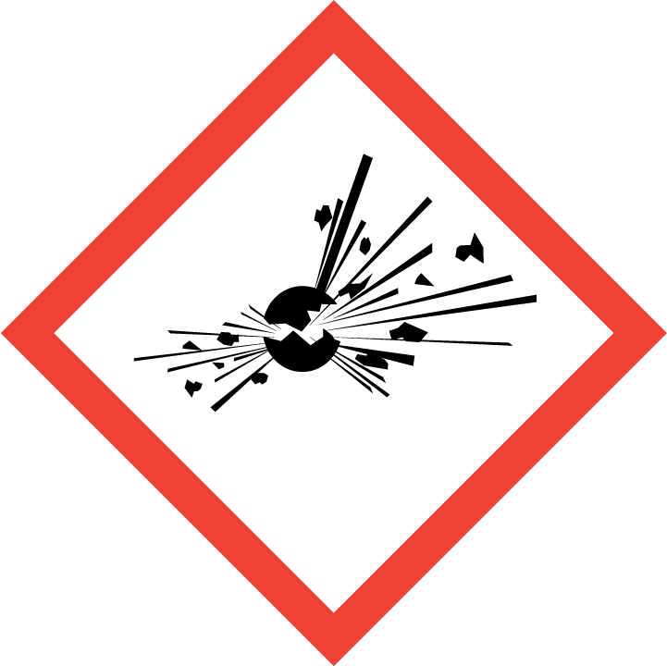 | 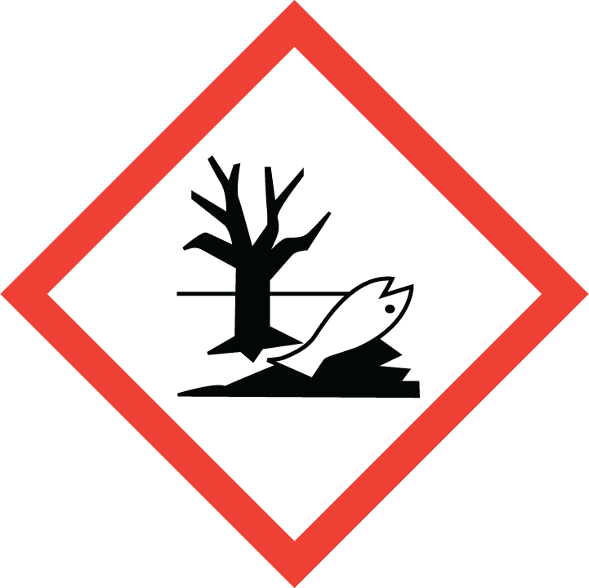 | 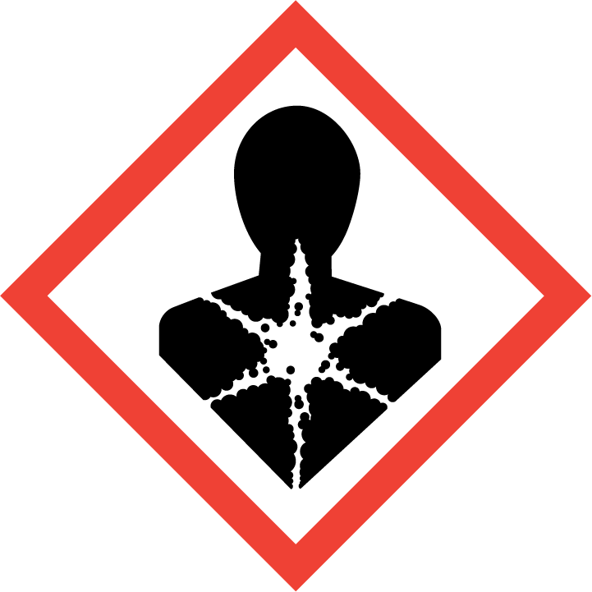
Flammable | Toxic | Harmful | Oxidising | Corrosive | Explosive | Harmful to the environment | Health Hazards i.e. respiratory sensitisation or carcinogenicity
 |  |  |  |  |  | 

SMOKING, EATING AND DRINKING ARE PROHIBITED IN THE WORK AREAS.
Information, Instruction and Training must be provided to all users. Young Persons, New or Expectant Mothers and other vulnerable groups must not use or be exposed to this product.

WORKPLACE EXPOSURE LIMITS (WEL’s)
IMPORTANT!
Refer to Workplace Exposure Levels information provided in the Manufacturers Safety Data and revise control measures if exposure levels likely to be reached.

ROUTE OF EXPOSURE
Skin |  | Eyes |  | Inhalation | 
Ingestion |  | Cuts/abrasions |  | Systemic

PERSONS AT RISK
User of product |  | Co workers |  | Members of the public

ROUTE OF EXPOSURE | 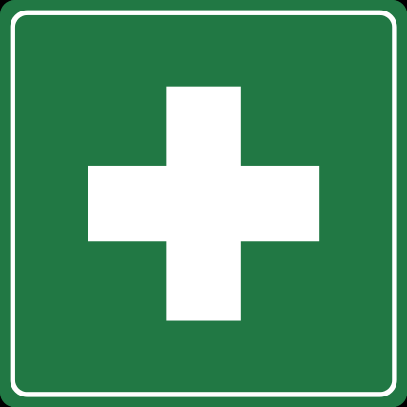  FIRST AID MEASURES
Eyes | Rinse immediately with plenty of running water (for 10 minutes), seek medical attention from a specialist.
Skin | Rinse with running water and soap.
Inhalation | Obtain medical attention if irritation persists.
Ingestion | Rinse mouth, drink 1-2 glasses of water, do not induce vomiting, consult a doctor
In all cases of doubt, or if symptoms persist seek medical attention. Never give anything by mouth to an unconscious person. If unconscious, place in recovery position and seek medical advice.

PERSONAL PROTECTIVE EQUIPMENT
 |  |  |  | 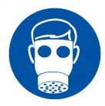 |  | 
YES | YES | YES/NO |  | YES/NO | YES | YES/NO
 |  |  |  |  | C
Wear glasses i | Normal work wear |  |  | N/A

HANDLING | STORAGE | TRANSPORT | DISPOSAL
Keep away from sources of ignition - no smoking.  Vapours should be extracted to avoid inhalation.  Use only in well-ventilated areas.  Avoid skin and eye contact. | Store in a cool, dry place.  Do not store near sources of heat or ignition, or reactive materials | Not classified as hazardous under CHIP or CLP. | Dispose of according to regulations.

REQUIRED CONTROL MEASURES
- Users to avoid contact with skin and eyes – Use PPE.
- Ensure operatives are made aware of and understand the purpose of this assessment and MSDS, plus any health implications of using the product.
- Ensure COSHH assessments with accompanying MSDS are made available for all employees and users and for inspection and emergency purpose.
- Wash promptly if skin becomes contaminated. Wash hands at the end of each work shift and before eating, smoking and using the toilet.

FIRE PRECAUTIONS
Suitable extinguishing agents:
Foam, extinguishing powder, carbon dioxide.

ACCIDENTAL RELEASE/SPILLAGE PROCEDURES
Remove possible causes of ignition. Do not smoke. Ensure sufficient air supply.

Protect drains from potential spills to minimise contamination. Do not wash product into drainage system. In the case of large spills contact the appropriate authorities.

MONITORING REQUIREMENTS AND HEALTH SURVEILLANCE
Health surveillance is not in place for workers exposed to this product.

